The Federal Emergency Management Agency (FEMA)
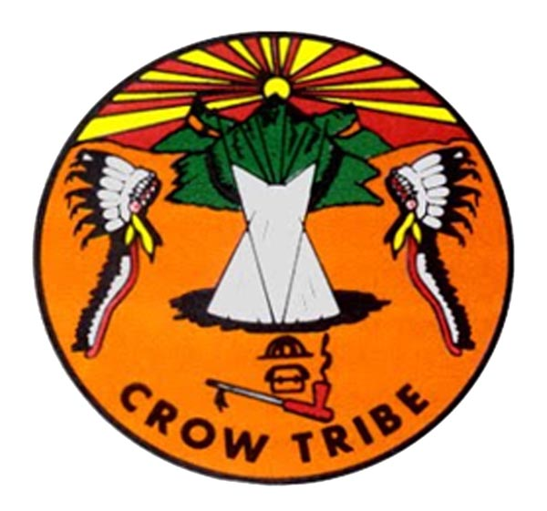
Emergency Management Institute (EMI)
and the
Crow Tribe
invite you to attend the
FEMA Emergency Management Framework
for Tribal Governments course (L0580)
August 26 - 29, 2024 from 8:00 am - 5:00 pm
At the Multi-Purpose Building, Off Hwy 90, Crow Agency, MT 59022

Course Purpose: To help ensure the protection of Tribal members and Tribal communities in times of disaster occurrences through gaining an understanding of your role in emergency management, critical plans, and comprehensive emergency management systems.
This 4-day course provides a basic understanding of emergency management principles, your role in planning and response, and how to better support your tribe in developing and implementing comprehensive emergency management systems.
Specific topics include
- Identification and analysis of hazards,
- Developing an Emergency Operations Plan (EOP) and other planning,
- Assuring readiness through training and exercises,
- Forming partnerships in the public and private sectors, and
- Upgrading and sustaining emergency management capabilities.

NOTE: ICS 100 and 200 are strongly recommended prior to taking this course.

Intended Audience: Tribal leaders, Tribal emergency managers/ emergency response personnel, Tribal government agency/department heads, and Tribal government employees.

The training and course materials are free
Travel expenses are the responsibility of the student’s organization

To sign up please contact
Sylvan Covers Up at (406) 623-0295 or at sylvan.coversup@crow-nsn.gov

Online registration is open (in-person registration will also be available at class)
- Please obtain a Student Identification Number: https://cdp.dhs.gov/femasid
- Link to apply online: National Emergency Training Center Online Admissions Application (fema.gov)
  - Course is L0580, Start Date: August 26, 2024 if registering online

HOTEL INFORMATION
Super 8 by Wyndham- 406-623-5777, 1324 N. Crawford Ave, Hardin, MT;
Homestead Inn and Suites, 833-577-4260, 201 14th St. W. Hardin, MT,
Lariat Motel, 833-483-0762, 709 N. Center Ave, Hardin, MT

AIRPORT INFORMATION
Billings Logan International Airport
1901 Terminal Cir., Billings, MT 59105
Approximately 60 miles, 1 hour

